**Project Design Phase-II**

**Data Flow Diagram &User Stories**

| Date | 10October 2022 |
| --- | --- |
| Team ID | PNT2022TMID04292 |
| Project Name | A Novel Method for Handwritten Digit Recognition System |
| Maximum Marks | 4 Marks |

**Data Flow Diagrams:**

A Data Flow Diagram (DFD) is a traditional visual representation of the information flows within a system. A neat and clear DFD can depict the right amount of the system requirement graphically. It shows how data enters and leaves the system, what changes the information, and where data is stored.

**Level 0 DFD**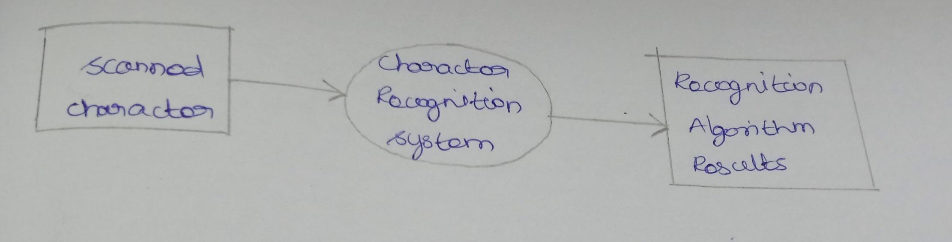

**Level 1 DFD**

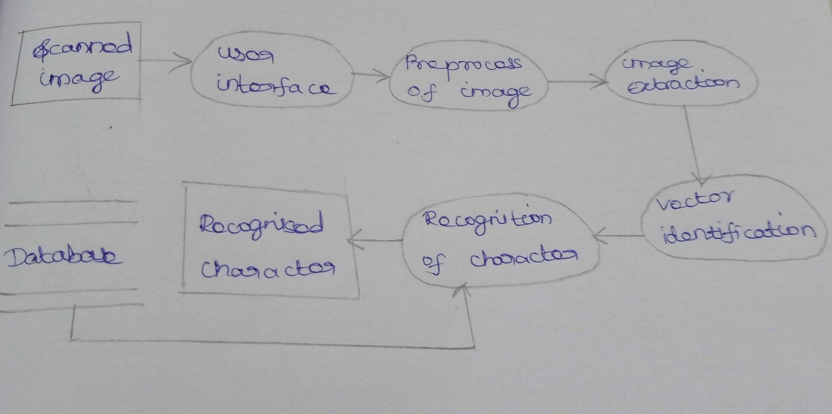

**Level 2 DFD**

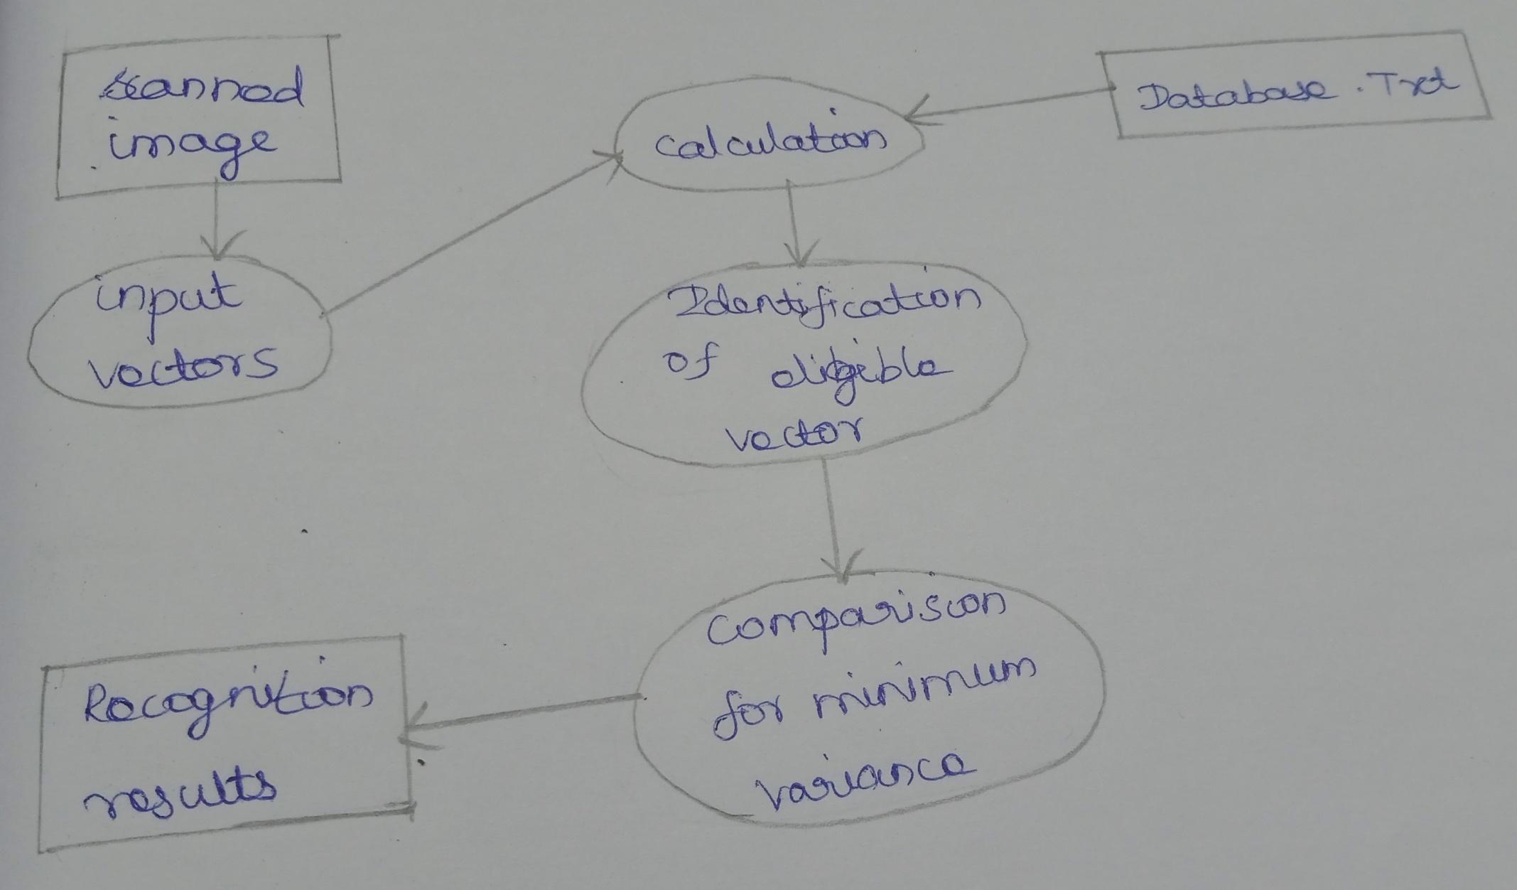

**User Stories**

| **User Type** | **Functional Requirement (Epic)** | **User Story Number** | **User Story / Task** | **Acceptance criteria** | **Priority** | **Release** |
| --- | --- | --- | --- | --- | --- | --- |
| Customer (Mobile user) | Registration | USN-1 | As a user, I can register for the application by entering my email, password, and confirming my password. | I can access my account / dashboard | High | Sprint-1 |
|  |  | USN-2 | As a user, I will receive confirmation email once I have registered for the application | I can receive confirmation email & click confirm | High | Sprint-1 |
|  |  | USN-3 | As a user, I can register for the application through Gmail | I can register & access the dashboard with Facebook Login | Medium | Sprint-1 |
|  | Login | USN-4 | As a user, I can log into the application by entering email & password |  | High | Sprint-1 |
|  | Dashboard | USN-5 | Go to dashboard and refer the content about our project |  | High | Sprint-1 |
| Customer (Web user) | Login | USN-1 | As a user, I can use the application by entering my email, password. | I can access my account | High | Sprint-1 |
| Customer Care Executive | Dashboard | USN-1 | upload the image | Recognize and get the output | High | Sprint-1 |
| Administrator | Security | USN-1 | updated the features | checking the security | Medium | Sprint-1 |